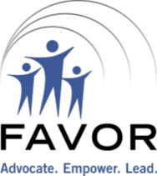
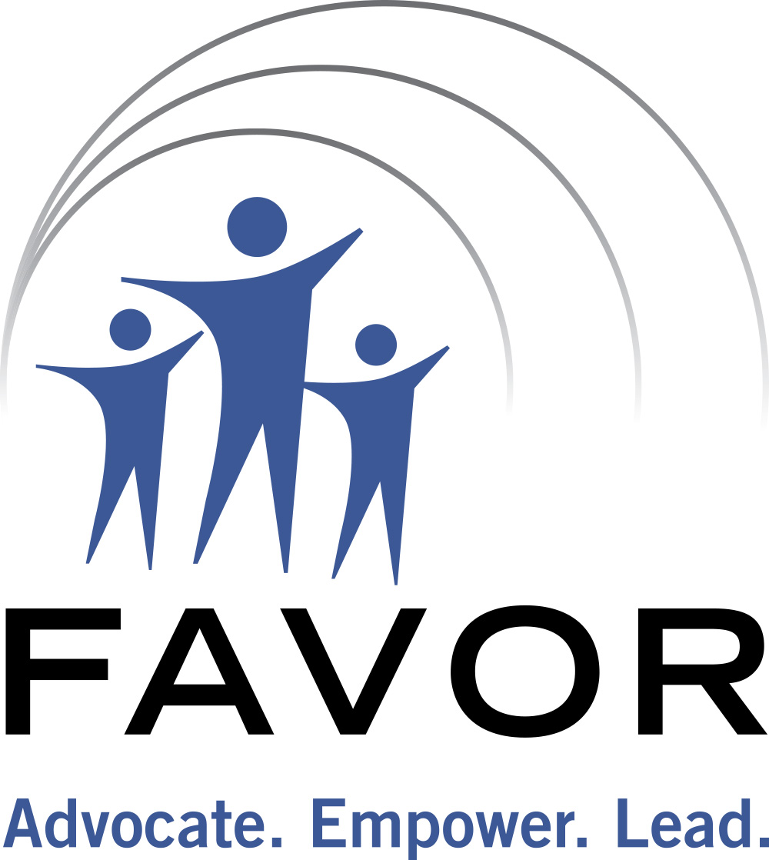
FAVOR FAMILY PEER SUPPORT
Brief Service Consultation Form
185 Silas Deane Highway
Wethersfield, CT 06109
Office: 860- 563-3232
Fax: 860- 563-3961
Email: refer@favor-ct.org
(front – to be completed by referral agency or person)
(back – to be completed by Family Peer Support Specialist)

Referral Source: DCF Discharge Date:

Referral Source Contact Information:

Parent/Guardian Name: Child’s Name:

Parent/Guardian DOB: Child’s DOB:

Address:

Phone: E-mail:

Is the PARENT/LEGAL GUARDIAN of Hispanic Origin? Yes No
Is the CHILD of Hispanic Origin? Yes No
Parent/Legal Guardian’s Race Child’s Race
American Indian or Alaska Native American Indian or Alaska Native
Native Hawaiian or Other Pacific Islander Native Hawaiian or Other Pacific Islander
Asian Asian
White White
Black or African American Black or African American
Other (Please Specify): ________________ Other (Please Specify): ________________

Presenting Issue(s) (Check all that apply)

Mental Health Services Early Intervention
Insurance Special Education
Medicaid Respite
Social Security Child Care
Title V Recreation
Other Financial Access to Health Care
Transition to Adulthood
Other Transition
Care Coordination
Parent to Parent
Family Leadership
Other: ________________

Nature of Concern with presenting issue:

Would you like to receive information regarding FAVOR meetings, conferences and trainings?
STAFF USE ONLY

Date Assign: __________________ Family Peer Support Specialist: _________________________

Date of Contact: Triage Coordinator:

Form of Contact to Parent/Caregiver: Phone Email Face-to-face
Form of Contact to Referral Source: Phone Email Face-to-face

NOTES:

FAMILY STRENGTHS:

FAMILY’S NATURAL AND/OR FORMAL SUPPORTS:

NEEDS:

ACTION STEPS:
Not eligible/Reason:

Diverted/Reason:
Sent Sample Letter for Initial Testing Sent Sample Letter for IEE
Sent Information Regarding Rights Gave Information Regarding Manifestation/Expulsion
Reviewed Documentation Referred to Care Coordination
Sent to FPSS Sent Release of Information
Referred to FSM Program/Verbal Consent Given
Gave information regarding Beacon ICC Program
Other:

